Study2_T3_Distribution PXpi sur DisX
Analyse automatique

1. Loading data
# Read
donnees <- read.csv2("Study2_Data_a.csv")
# Correct the type of useful columns
donnees <- donnees %>%
mutate(across(c(Session, Task), as.factor),
Bias = as.factor(Bias),
PXpi = as.numeric(PXpi),
DisX = as.numeric(DisX))
# Keep only task T3 and remove Subject ‘C.’ and empty Subjects.
donnees_T3 <- donnees %>%
filter(Task == "T3") %>%
filter(!is.na(Subject), Subject != "", Subject != "C.")

2. Roll out the data according to the PXpi weight (uncount)
# Roll out the data according to the PXpi weight
donnees_T3_exp <- uncount(donnees_T3, weights = PXpi)

3. Boxplots de DisX (par Session et Bias)
ggplot(donnees_T3_exp, aes(x = Session, y = DisX, fill = Bias)) +
geom_boxplot(outlier.shape = NA, position = position_dodge(width = 0.75)) +
labs(title = "Distribution of presence on X (DisX) in T3 by Session and Bias",
y = "DisX", x = "Session", fill = "Bias") +
coord_cartesian(ylim = c(-800, 800)) +
theme_minimal()
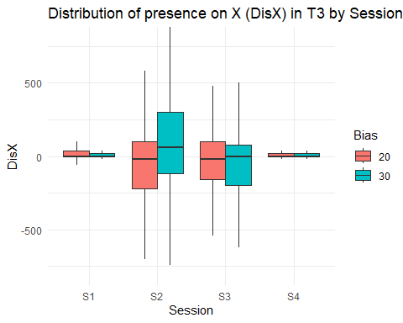

4. Weighted statistics
# Function for weighted variance
weighted_var <- function(x, w) {
m <- weighted.mean(x, w)
sum(w * (x - m)^2) / sum(w)
}
# Calculation of statistics by group
stats_pond <- donnees_T3 %>%
group_by(Session, Bias) %>%
summarise(
n = sum(PXpi),
Moyenne = weighted.mean(DisX, PXpi),
Variance = weighted_var(DisX, PXpi),
.groups = "drop"
)
kable(stats_pond, digits = 2, caption = "DisX weighted statistics by Session and Bias")
DisX weighted statistics by Session and Bias
Session | Bias | n | Moyenne | Variance
S1 | 20 | 205736 | 14.86 | 12561.74
S1 | 30 | 210626 | 4.34 | 2786.89
S2 | 20 | 104041 | -64.64 | 105658.03
S2 | 30 | 81742 | -0.57 | 258107.42
S3 | 20 | 107123 | -40.25 | 179400.06
S3 | 30 | 94039 | -98.00 | 284791.47
S4 | 20 | 211995 | -15.02 | 38437.75
S4 | 30 | 225515 | 13.75 | 3167.04

5. Levene’s test ( by pairs and by bias)
sessions <- c("S1", "S2", "S3", "S4")
Biass <- unique(donnees_T3_exp$Bias)
paires <- combn(sessions, 2, simplify = FALSE)
# Fonction test Levene
tester_paire_levene_Bias <- function(pair, Bias, data) {
df <- data %>% filter(Session %in% pair, Bias == Bias)
if (nrow(df) < 2) return(NULL)
res <- leveneTest(DisX ~ Session, data = df)
pval <- res$`Pr(>F)`[1]
data.frame(Bias = Bias, Session1 = pair[1], Session2 = pair[2], p_value = round(pval, 4))
}
# Apply for each pair and Bias
resultats_levene <- map_dfr(Biass, function(a) {
map_dfr(paires, ~tester_paire_levene_Bias(.x, a, donnees_T3_exp))
})
kable(resultats_levene, caption = "Levene's test by pairs of sessions and by bias")
Levene’s test by pairs of sessions and by bias
Bias | Session1 | Session2 | p_value
30 | S1 | S2 | 0.0000
30 | S1 | S3 | 0.0000
30 | S1 | S4 | 0.0000
30 | S2 | S3 | 0.0398
30 | S2 | S4 | 0.0000
30 | S3 | S4 | 0.0000
20 | S1 | S2 | 0.0000
20 | S1 | S3 | 0.0000
20 | S1 | S4 | 0.0000
20 | S2 | S3 | 0.0398
20 | S2 | S4 | 0.0000
20 | S3 | S4 | 0.0000

6. Conclusion
resultats_signif <- resultats_levene %>% filter(p_value < 0.05)
if (nrow(resultats_signif) > 0) {
cat("✅ Csignificantly different comparisons(p < 0.05) :\n\n")
resultats_signif %>%
mutate(commentaire = paste0("- À l'Bias ", Bias, "°, The variance differs between ", Session1, " and ", Session2, " (p = ", p_value, ").")) %>%
pull(commentaire) %>%
cat(sep = "\n")
} else {
cat("❌ Ano significant difference in variance detected between sessions.")
}
## ✅ Csignificantly different comparisons(p < 0.05) :
##
## - À l'Bias 30°, The variance differs between S1 and S2 (p = 0).
## - À l'Bias 30°, The variance differs between S1 and S3 (p = 0).
## - À l'Bias 30°, The variance differs between S1 and S4 (p = 0).
## - À l'Bias 30°, The variance differs between S2 and S3 (p = 0.0398).
## - À l'Bias 30°, The variance differs between S2 and S4 (p = 0).
## - À l'Bias 30°, The variance differs between S3 and S4 (p = 0).
## - À l'Bias 20°, The variance differs between S1 and S2 (p = 0).
## - À l'Bias 20°, The variance differs between S1 and S3 (p = 0).
## - À l'Bias 20°, The variance differs between S1 and S4 (p = 0).
## - À l'Bias 20°, The variance differs between S2 and S3 (p = 0.0398).
## - À l'Bias 20°, The variance differs between S2 and S4 (p = 0).
## - À l'Bias 20°, The variance differs between S3 and S4 (p = 0).

