Study2_DisY-Bias 30
Weighted analysis — Sessions S2-S3 — Tâches T1-T2

1. Data loading and preparation
donnees <- read.csv2("Study2_Data-Ya.csv")
donnees <- donnees %>%
mutate(across(c(Session, Task, Instruction, Subject), as.factor),
Bias = as.factor(Bias),
PYpi = as.numeric(PYpi),
DisY = as.numeric(DisY)) %>%
filter(Task %in% c("T1", "T2"),
Subject %in% c("A", "B"),
Session %in% c("S2", "S3"),
Instruction %in% c("R", "L"),
Bias == 30)

2. Weighted statistics: Mean and median
stats_disy <- donnees %>%
group_by(Session, Task, Instruction, Subject) %>%
summarise(
Mean = weighted.mean(DisY, w = PYpi),
Median = wtd.quantile(DisY, weights = PYpi, probs = 0.5),
.groups = "drop"
) %>%
arrange(Session, Task, Subject)
kable(stats_disy, digits = 2, caption = "DisY weighted stat. by subject and instruct. Bias 30°")
DisY weighted stat. by subject and instruct. Bias 30°
Session | Task | Instruction | Subject | Mean | Median
S2 | T1 | L | A | -18.24 | 0
S2 | T1 | R | A | -1.01 | -12
S2 | T1 | L | B | 44.59 | 12
S2 | T1 | R | B | -2.37 | -12
S2 | T2 | L | A | -10.66 | -12
S2 | T2 | R | A | -15.49 | -12
S2 | T2 | L | B | 28.64 | 12
S2 | T2 | R | B | -20.93 | -12
S3 | T1 | L | A | -9.45 | -12
S3 | T1 | R | A | -5.96 | -12
S3 | T1 | L | B | 20.29 | 12
S3 | T1 | R | B | -5.64 | 0
S3 | T2 | L | A | -16.53 | -12
S3 | T2 | R | A | -9.04 | -12
S3 | T2 | L | B | 28.97 | 12
S3 | T2 | R | B | -25.48 | -12

3. Visualization: directional arrow chart
ggplot(stats_disy, aes(x = Instruction, y = Mean, group = Subject, color = Subject)) +
geom_point(size = 3) +
geom_line(arrow = arrow(length = unit(0.2, "cm")), linewidth = 1) +
facet_grid(rows = vars(Session), cols = vars(Task), labeller = label_both) +
labs(title = "Directional trend on DisY Subjects A and B, Bias 30°",
x = "Instruction", y = "Weighted mean of DisY") +
theme_minimal()
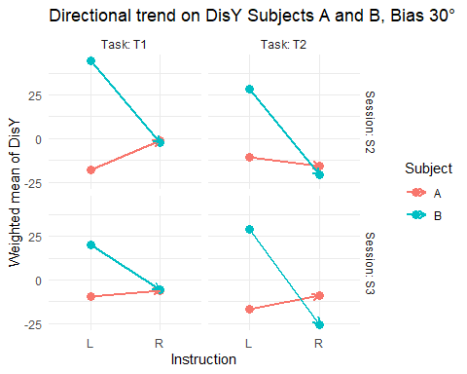

4. Visualization: comparative bar chart
ggplot(stats_disy, aes(x = Instruction, y = Mean, fill = Subject)) +
geom_bar(stat = "identity", position = position_dodge(width = 0.7), width = 0.6) +
facet_grid(rows = vars(Session), cols = vars(Task), labeller = label_both) +
labs(title = "Weighted mean comparison of DisY, A vs. B, Bias 30°",
y = "DisY (Weighted mean)", x = "Instruction") +
theme_minimal()
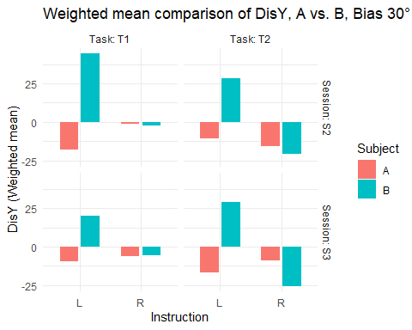

5. Statistical interaction test (ANOVA)
donnees_deroulees <- tidyr::uncount(donnees, weights = PYpi)
modeles <- donnees_deroulees %>%
group_by(Session, Task) %>%
summarise(
Modèle = list(aov(DisY ~ Instruction * Subject, data = pick(everything()))),
.groups = "drop"
) %>%
mutate(Resultat = map(Modèle, broom::tidy)) %>%
unnest(Resultat)
kable(modeles %>%
filter(term == "Instruction:Subject") %>%
select(Session, Task, term, statistic, p.value),
digits = 4,
caption = "Interaction test, Instruction × Subject sur DisY (ANOVA)")
Interaction test, Instruction × Subject sur DisY (ANOVA)
Session | Task | term | statistic | p.value
S2 | T1 | Instruction:Subject | 5594.982 | 0
S2 | T2 | Instruction:Subject | 1814.820 | 0
S3 | T1 | Instruction:Subject | 2171.872 | 0
S3 | T2 | Instruction:Subject | 5682.630 | 0

6. Wilcoxon nonparametric tests
tests_wilcoxon <- donnees_deroulees %>%
group_by(Session, Task, Instruction) %>%
filter(n_distinct(Subject) == 2) %>%
group_modify(~ broom::tidy(wilcox.test(DisY ~ Subject, data = .x, exact = FALSE))) %>%
ungroup()
kable(tests_wilcoxon, digits = 4, caption = "Wilcoxon test—comparison A vs. B in each Instruction")
Wilcoxon test—comparison A vs. B in each Instruction
Session | Task | Instruction | statistic | p.value | method | alternative
S2 | T1 | L | 53072617 | 0.0000 | Wilcoxon rank sum test with continuity correction | two.sided
S2 | T1 | R | 82602770 | 0.0368 | Wilcoxon rank sum test with continuity correction | two.sided
S2 | T2 | L | 17361232 | 0.0000 | Wilcoxon rank sum test with continuity correction | two.sided
S2 | T2 | R | 39488042 | 0.0000 | Wilcoxon rank sum test with continuity correction | two.sided
S3 | T1 | L | 70930151 | 0.0000 | Wilcoxon rank sum test with continuity correction | two.sided
S3 | T1 | R | 103534475 | 0.0000 | Wilcoxon rank sum test with continuity correction | two.sided
S3 | T2 | L | 24180695 | 0.0000 | Wilcoxon rank sum test with continuity correction | two.sided
S3 | T2 | R | 27163542 | 0.0000 | Wilcoxon rank sum test with continuity correction | two.sided

