Study2_DisY-Bias-20
Weighted analysis — Sessions S2-S3 — Tâches T1-T2

1. Data loading and preparation
donnees <- read.csv2("Study2_Data-Ya.csv")
donnees <- donnees %>%
mutate(across(c(Session, Task, Instruction, Subject), as.factor),
Bias = as.factor(Bias),
PYpi = as.numeric(PYpi),
DisY = as.numeric(DisY)) %>%
filter(Task %in% c("T1", "T2"),
Subject %in% c("A", "B"),
Session %in% c("S2", "S3"),
Instruction %in% c("R", "L"),
Bias == 20)

2. Weighted statistics: Mean and median
stats_disy <- donnees %>%
group_by(Session, Task, Instruction, Subject) %>%
summarise(
Mean = weighted.mean(DisY, w = PYpi),
Median = wtd.quantile(DisY, weights = PYpi, probs = 0.5),
.groups = "drop"
) %>%
arrange(Session, Task, Subject)
kable(stats_disy, digits = 2, caption = "DisY weighted stat. by subject and instruct., Bias 20°")
DisY weighted stat. by subject and instruct., Bias 20°
Session | Task | Instruction | Subject | Mean | Median
S2 | T1 | L | A | -6.73 | -12
S2 | T1 | R | A | 3.72 | 12
S2 | T1 | L | B | 19.94 | 12
S2 | T1 | R | B | -13.90 | -12
S2 | T2 | L | A | -4.87 | 0
S2 | T2 | R | A | -8.13 | 0
S2 | T2 | L | B | 21.83 | 12
S2 | T2 | R | B | -25.53 | -12
S3 | T1 | L | A | -7.38 | -12
S3 | T1 | R | A | 1.79 | -12
S3 | T1 | L | B | 31.32 | 12
S3 | T1 | R | B | -33.58 | -12
S3 | T2 | L | A | 2.78 | -12
S3 | T2 | R | A | -24.85 | -12
S3 | T2 | L | B | 42.68 | 37
S3 | T2 | R | B | -58.45 | -62

3. Visualization: directional arrow chart
ggplot(stats_disy, aes(x = Instruction, y = Mean, group = Subject, color = Subject)) +
geom_point(size = 3) +
geom_line(arrow = arrow(length = unit(0.2, "cm")), linewidth = 1) +
facet_grid(rows = vars(Session), cols = vars(Task), labeller = label_both) +
labs(title = "Directional trend on DisY, Subjects A and B, Bias 20°",
x = "Instruction", y = "Mean pondérée de DisY") +
theme_minimal()
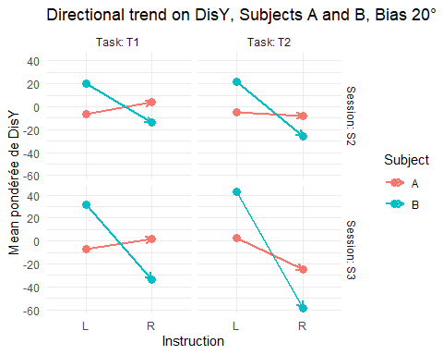

4. Visualization: comparative bar chart
ggplot(stats_disy, aes(x = Instruction, y = Mean, fill = Subject)) +
geom_bar(stat = "identity", position = position_dodge(width = 0.7), width = 0.6) +
facet_grid(rows = vars(Session), cols = vars(Task), labeller = label_both) +
labs(title = "Weighted average comparison of DisY — A vs. B, Bias 20°",
y = "DisY (Mean pondérée)", x = "Instruction") +
theme_minimal()
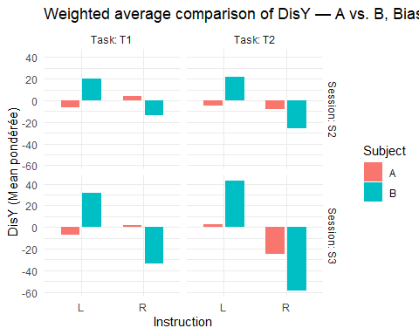

5. Statistical interaction test (ANOVA)
donnees_deroulees <- tidyr::uncount(donnees, weights = PYpi)
modeles <- donnees_deroulees %>%
group_by(Session, Task) %>%
summarise(
Modèle = list(aov(DisY ~ Instruction * Subject, data = pick(everything()))),
.groups = "drop"
) %>%
mutate(Resultat = map(Modèle, broom::tidy)) %>%
unnest(Resultat)
kable(modeles %>%
filter(term == "Instruction:Subject") %>%
select(Session, Task, term, statistic, p.value),
digits = 4,
caption = "Interaction test Instruction × Subject on DisY (ANOVA) Bias 20°")
Interaction test Instruction × Subject on DisY (ANOVA) Bias 20°
Session | Task | term | statistic | p.value
S2 | T1 | Instruction:Subject | 7536.518 | 0
S2 | T2 | Instruction:Subject | 3908.926 | 0
S3 | T1 | Instruction:Subject | 16312.861 | 0
S3 | T2 | Instruction:Subject | 6338.596 | 0

6. Wilcoxon nonparametric tests
tests_wilcoxon <- donnees_deroulees %>%
group_by(Session, Task, Instruction) %>%
filter(n_distinct(Subject) == 2) %>%
group_modify(~ broom::tidy(wilcox.test(DisY ~ Subject, data = .x, exact = FALSE))) %>%
ungroup()
kable(tests_wilcoxon, digits = 4, caption = "Wilcoxon test — comparison of A vs. B in each instruction")
Wilcoxon test — comparison of A vs. B in each instruction
Session | Task | Instruction | statistic | p.value | method | alternative
S2 | T1 | L | 94666419 | 0 | Wilcoxon rank sum test with continuity correction | two.sided
S2 | T1 | R | 233928695 | 0 | Wilcoxon rank sum test with continuity correction | two.sided
S2 | T2 | L | 75276852 | 0 | Wilcoxon rank sum test with continuity correction | two.sided
S2 | T2 | R | 97655437 | 0 | Wilcoxon rank sum test with continuity correction | two.sided
S3 | T1 | L | 261719562 | 0 | Wilcoxon rank sum test with continuity correction | two.sided
S3 | T1 | R | 382222551 | 0 | Wilcoxon rank sum test with continuity correction | two.sided
S3 | T2 | L | 40993104 | 0 | Wilcoxon rank sum test with continuity correction | two.sided
S3 | T2 | R | 99305144 | 0 | Wilcoxon rank sum test with continuity correction | two.sided

