Study 1 — DisX distribution and kinematic analyses (weighted)

Helpers robustes
w_mean <- function(x, w) stats::weighted.mean(x, w, na.rm = TRUE)
w_var <- function(x, w) {
# weighted variance Hmisc (diviseur = sum(w), pas (sum(w)-1))
ok <- is.finite(x) & is.finite(w)
x <- x[ok]; w <- w[ok]
if (length(x) == 0 || sum(w) == 0) return(NA_real_)
m <- stats::weighted.mean(x, w)
sum(w * (x - m)^2) / sum(w)
}
w_q <- function(x, w, probs)
# weighted quantiles via Hmisc
Hmisc::wtd.quantile(x, weights = w, probs = probs, na.rm = TRUE, type = "i/n")

1) Data import & structure
library(readr)
library(dplyr)
# Main dataset
Study1 <- read_delim(
"Study1_Data_a.csv",
delim = ";",
locale = locale(decimal_mark = "."),
show_col_types = FALSE,
trim_ws = TRUE
)
# Keep only Sessions S1–S3 for the main analyses
datat <- dplyr::filter(Study1, Session %in% c("S1","S2","S3"))
head(datat); str(datat)
## # A tibble: 6 × 12
## Binome Session Trial Subject Bias DisX PXpg PXpi VXg VXi AXg AXi
## <chr> <chr> <chr> <chr> <dbl> <dbl> <dbl> <dbl> <dbl> <dbl> <dbl> <dbl>
## 1 B1 S1 E1 A 30 -2000 0 0 NA NA NA NA
## 2 B1 S1 E1 A 30 -1980 0 0 NA NA NA NA
## 3 B1 S1 E1 A 30 -1960 0 0 NA NA NA NA
## 4 B1 S1 E1 A 30 -1940 0 0 NA NA NA NA
## 5 B1 S1 E1 A 30 -1920 0 0 NA NA NA NA
## 6 B1 S1 E1 A 30 -1900 0 0 NA NA NA NA
## spc_tbl_ [64,320 × 12] (S3: spec_tbl_df/tbl_df/tbl/data.frame)
## $ Binome : chr [1:64320] "B1" "B1" "B1" "B1" ...
## $ Session: chr [1:64320] "S1" "S1" "S1" "S1" ...
## $ Trial : chr [1:64320] "E1" "E1" "E1" "E1" ...
## $ Subject: chr [1:64320] "A" "A" "A" "A" ...
## $ Bias : num [1:64320] 30 30 30 30 30 30 30 30 30 30 ...
## $ DisX : num [1:64320] -2000 -1980 -1960 -1940 -1920 -1900 -1880 -1860 -1840 -1820 ...
## $ PXpg : num [1:64320] 0 0 0 0 0 0 0 0 0 0 ...
## $ PXpi : num [1:64320] 0 0 0 0 0 0 0 0 0 0 ...
## $ VXg : num [1:64320] NA NA NA NA NA NA NA NA NA NA ...
## $ VXi : num [1:64320] NA NA NA NA NA NA NA NA NA NA ...
## $ AXg : num [1:64320] NA NA NA NA NA NA NA NA NA NA ...
## $ AXi : num [1:64320] NA NA NA NA NA NA NA NA NA NA ...
## - attr(*, "spec")=
## .. cols(
## .. Binome = col_character(),
## .. Session = col_character(),
## .. Trial = col_character(),
## .. Subject = col_character(),
## .. Bias = col_double(),
## .. DisX = col_double(),
## .. PXpg = col_double(),
## .. PXpi = col_double(),
## .. VXg = col_double(),
## .. VXi = col_double(),
## .. AXg = col_double(),
## .. AXi = col_double()
## .. )
## - attr(*, "problems")=<externalptr>

2) Filtering, expanding (by weights), and boxplots
# Keep S1–S3 and remove artificial DisX sentinels
filtered_data <- Study1 %>%
dplyr::filter(Session %in% c("S1","S2","S3")) %>%
dplyr::filter(DisX != 2000 & DisX != -2000)
# Expand rows: each DisX replicated PXpi times (for visualization like boxplots)
expanded_data <- filtered_data %>% tidyr::uncount(PXpi)
# Boxplots of DisX by Bias and Session (no outlier points)
ggplot(expanded_data, aes(x = factor(Bias), y = DisX, fill = factor(Session))) +
geom_boxplot(outlier.shape = NA) +
labs(
title = "Distribution of DisX by Session and Bias",
x = "Bias (°)",
y = "Position (DisX)",
fill = "Session"
) +
facet_wrap(~ Session, scales = "free_x") +
theme_minimal() +
scale_fill_brewer(palette = "Set2")
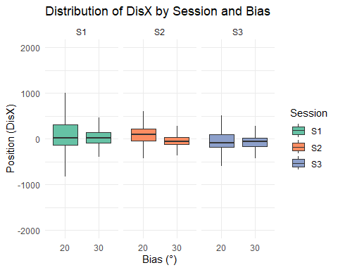

3) Weighted descriptive statistics (DisX)
# Weighted mean / quantiles / variance / SD by Session × Bias
weighted_stats <- filtered_data %>%
dplyr::group_by(Session, Bias) %>%
dplyr::summarise(
weighted_mean = w_mean(DisX, PXpi),
weighted_median = w_q(DisX, PXpi, 0.5),
Q1_weighted = w_q(DisX, PXpi, 0.25),
Q3_weighted = w_q(DisX, PXpi, 0.75),
weighted_var = w_var(DisX, PXpi),
weighted_sd = sqrt(w_var(DisX, PXpi)),
.groups = "drop"
)
knitr::kable(weighted_stats, digits = 3, caption = "Weighted descriptive statistics for DisX (by Session × Bias)")
Weighted descriptive statistics for DisX (by Session × Bias)
Session | Bias | weighted_mean | weighted_median | Q1_weighted | Q3_weighted | weighted_var | weighted_sd
S1 | 20 | 108.578 | 9.971 | -149.135 | 302.347 | 160204.29 | 400.255
S1 | 30 | 72.489 | 10.528 | -87.795 | 127.647 | 108451.45 | 329.320
S2 | 20 | 96.933 | 82.094 | -41.251 | 206.035 | 109188.78 | 330.437
S2 | 30 | -26.448 | -60.090 | -137.005 | 30.795 | 38517.36 | 196.258
S3 | 20 | -37.559 | -85.117 | -198.735 | 95.025 | 96734.13 | 311.021
S3 | 30 | -66.039 | -76.666 | -173.083 | 4.452 | 20826.59 | 144.314

4) Levene’s test (homogeneity of variance) by session
# Rebuild expanded_data (if chunk run alone)
if(!exists("expanded_data")){
expanded_data <- Study1 %>%
dplyr::filter(Session %in% c("S1","S2","S3"),
DisX != 2000, DisX != -2000) %>%
tidyr::uncount(PXpi)
}
levene_by_session <- function(sess){
cat("\n--- Levene’s Test for Session", sess, "---\n")
d <- expanded_data %>% dplyr::filter(Session == sess, Bias %in% c(20,30))
if(nrow(d) > 0 && length(unique(d$Bias)) == 2){
lv <- car::leveneTest(DisX ~ factor(Bias), data = d)
print(lv)
invisible(lv)
} else {
cat("Not enough data for Bias 20 and 30 in Session", sess, "\n")
invisible(NULL)
}
}
lv_S1 <- levene_by_session("S1")
##
## --- Levene’s Test for Session S1 ---
## Levene's Test for Homogeneity of Variance (center = median)
## Df F value Pr(>F)
## group 1 4354.7 < 2.2e-16 ***
## 174381
## ---
## Signif. codes: 0 '***' 0.001 '**' 0.01 '*' 0.05 '.' 0.1 ' ' 1
lv_S2 <- levene_by_session("S2")
##
## --- Levene’s Test for Session S2 ---
## Levene's Test for Homogeneity of Variance (center = median)
## Df F value Pr(>F)
## group 1 3131.4 < 2.2e-16 ***
## 135054
## ---
## Signif. codes: 0 '***' 0.001 '**' 0.01 '*' 0.05 '.' 0.1 ' ' 1
lv_S3 <- levene_by_session("S3")
##
## --- Levene’s Test for Session S3 ---
## Levene's Test for Homogeneity of Variance (center = median)
## Df F value Pr(>F)
## group 1 13497 < 2.2e-16 ***
## 139661
## ---
## Signif. codes: 0 '***' 0.001 '**' 0.01 '*' 0.05 '.' 0.1 ' ' 1

5) Visualizing weighted standard deviations
# Bar plot: weighted SD by Session and Bias
ggplot(weighted_stats, aes(x = factor(Bias), y = weighted_sd, fill = factor(Bias))) +
geom_col(position = position_dodge(width = 0.8), color = "black") +
geom_text(aes(label = round(weighted_sd, 1)),
position = position_dodge(width = 0.8), vjust = -0.5, size = 3.2) +
labs(
title = "Weighted Standard Deviation of DisX by Session and Bias",
x = "Bias (°)",
y = "Weighted Standard Deviation"
) +
facet_wrap(~ Session, scales = "free_y") +
theme_minimal() +
theme(legend.position = "none") +
scale_fill_brewer(palette = "Paired")
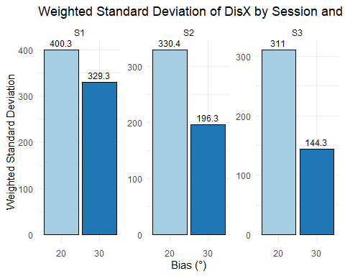

6) Velocity & Acceleration analyses
# Preprocess for kinematic analyses
kin_data <- Study1 %>%
dplyr::filter(Session %in% c("S1","S2","S3")) %>%
dplyr::filter(DisX != 2000 & DisX != -2000) %>%
dplyr::mutate(AbsVelocity = abs(VXi))
head(kin_data); dplyr::glimpse(kin_data)
## # A tibble: 6 × 13
## Binome Session Trial Subject Bias DisX PXpg PXpi VXg VXi AXg AXi
## <chr> <chr> <chr> <chr> <dbl> <dbl> <dbl> <dbl> <dbl> <dbl> <dbl> <dbl>
## 1 B1 S1 E1 A 30 -1980 0 0 NA NA NA NA
## 2 B1 S1 E1 A 30 -1960 0 0 NA NA NA NA
## 3 B1 S1 E1 A 30 -1940 0 0 NA NA NA NA
## 4 B1 S1 E1 A 30 -1920 0 0 NA NA NA NA
## 5 B1 S1 E1 A 30 -1900 0 0 NA NA NA NA
## 6 B1 S1 E1 A 30 -1880 0 0 NA NA NA NA
## # ℹ 1 more variable: AbsVelocity <dbl>
## Rows: 63,680
## Columns: 13
## $ Binome <chr> "B1", "B1", "B1", "B1", "B1", "B1", "B1", "B1", "B1", "B1"…
## $ Session <chr> "S1", "S1", "S1", "S1", "S1", "S1", "S1", "S1", "S1", "S1"…
## $ Trial <chr> "E1", "E1", "E1", "E1", "E1", "E1", "E1", "E1", "E1", "E1"…
## $ Subject <chr> "A", "A", "A", "A", "A", "A", "A", "A", "A", "A", "A", "A"…
## $ Bias <dbl> 30, 30, 30, 30, 30, 30, 30, 30, 30, 30, 30, 30, 30, 30, 30…
## $ DisX <dbl> -1980, -1960, -1940, -1920, -1900, -1880, -1860, -1840, -1…
## $ PXpg <dbl> 0, 0, 0, 0, 0, 0, 0, 0, 0, 0, 0, 0, 0, 0, 0, 0, 0, 0, 0, 0…
## $ PXpi <dbl> 0, 0, 0, 0, 0, 0, 0, 0, 0, 0, 0, 0, 0, 0, 0, 0, 0, 0, 0, 0…
## $ VXg <dbl> NA, NA, NA, NA, NA, NA, NA, NA, NA, NA, NA, NA, NA, NA, NA…
## $ VXi <dbl> NA, NA, NA, NA, NA, NA, NA, NA, NA, NA, NA, NA, NA, NA, NA…
## $ AXg <dbl> NA, NA, NA, NA, NA, NA, NA, NA, NA, NA, NA, NA, NA, NA, NA…
## $ AXi <dbl> NA, NA, NA, NA, NA, NA, NA, NA, NA, NA, NA, NA, NA, NA, NA…
## $ AbsVelocity <dbl> NA, NA, NA, NA, NA, NA, NA, NA, NA, NA, NA, NA, NA, NA, NA…

6.1 Weighted descriptive stats of absolute velocity by DisX
velocity_stats <- kin_data %>%
dplyr::group_by(Session, Bias, DisX) %>%
dplyr::summarise(
mean_abs_velocity_w = w_mean(AbsVelocity, PXpi),
var_abs_velocity_w = w_var(AbsVelocity, PXpi),
sd_abs_velocity_w = sqrt(w_var(AbsVelocity, PXpi)),
.groups = 'drop'
)
#knitr::kable(head(velocity_stats), digits = 3,
#caption = "Weighted absolute velocity statistics by position (DisX)")

6.2 Plots: weighted mean / variance of absolute velocity vs DisX
ggplot(velocity_stats, aes(x = DisX, y = mean_abs_velocity_w, color = factor(Bias))) +
geom_point(alpha = 0.6) +
geom_smooth(method = "loess", se = FALSE, span = 0.5) +
labs(
title = "Weighted Mean of Absolute Velocity by Position (DisX)",
x = "Position (DisX)",
y = "Weighted Mean of Absolute Velocity",
color = "Bias (°)"
) +
facet_wrap(~ Session, scales = "free_y") +
theme_minimal() +
scale_color_brewer(palette = "Set1")
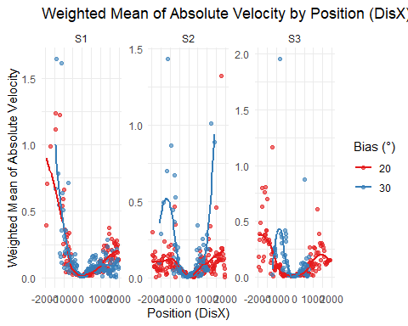
ggplot(velocity_stats, aes(x = DisX, y = var_abs_velocity_w, color = factor(Bias))) +
geom_point(alpha = 0.6) +
geom_smooth(method = "loess", se = FALSE, span = 0.5) +
labs(
title = "Weighted Variance of Absolute Velocity by Position (DisX)",
x = "Position (DisX)",
y = "Weighted Variance of Absolute Velocity",
color = "Bias (°)"
) +
facet_wrap(~ Session, scales = "free_y") +
theme_minimal() +
scale_color_brewer(palette = "Set1")
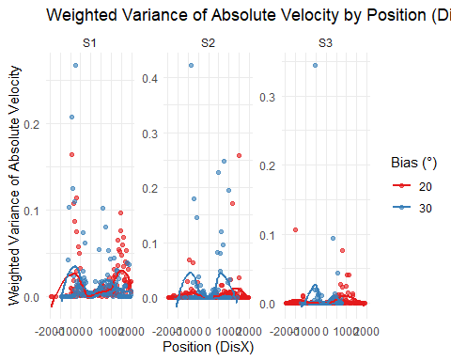

6.3 Acceleration vs DisX with weighted linear regression
Acc_data <- Study1 %>%
dplyr::filter(Session %in% c("S1","S2","S3")) %>%
dplyr::filter(DisX != 2000 & DisX != -2000)
head(Acc_data); dplyr::glimpse(Acc_data)
## # A tibble: 6 × 12
## Binome Session Trial Subject Bias DisX PXpg PXpi VXg VXi AXg AXi
## <chr> <chr> <chr> <chr> <dbl> <dbl> <dbl> <dbl> <dbl> <dbl> <dbl> <dbl>
## 1 B1 S1 E1 A 30 -1980 0 0 NA NA NA NA
## 2 B1 S1 E1 A 30 -1960 0 0 NA NA NA NA
## 3 B1 S1 E1 A 30 -1940 0 0 NA NA NA NA
## 4 B1 S1 E1 A 30 -1920 0 0 NA NA NA NA
## 5 B1 S1 E1 A 30 -1900 0 0 NA NA NA NA
## 6 B1 S1 E1 A 30 -1880 0 0 NA NA NA NA
## Rows: 63,680
## Columns: 12
## $ Binome <chr> "B1", "B1", "B1", "B1", "B1", "B1", "B1", "B1", "B1", "B1", "B…
## $ Session <chr> "S1", "S1", "S1", "S1", "S1", "S1", "S1", "S1", "S1", "S1", "S…
## $ Trial <chr> "E1", "E1", "E1", "E1", "E1", "E1", "E1", "E1", "E1", "E1", "E…
## $ Subject <chr> "A", "A", "A", "A", "A", "A", "A", "A", "A", "A", "A", "A", "A…
## $ Bias <dbl> 30, 30, 30, 30, 30, 30, 30, 30, 30, 30, 30, 30, 30, 30, 30, 30…
## $ DisX <dbl> -1980, -1960, -1940, -1920, -1900, -1880, -1860, -1840, -1820,…
## $ PXpg <dbl> 0, 0, 0, 0, 0, 0, 0, 0, 0, 0, 0, 0, 0, 0, 0, 0, 0, 0, 0, 0, 0,…
## $ PXpi <dbl> 0, 0, 0, 0, 0, 0, 0, 0, 0, 0, 0, 0, 0, 0, 0, 0, 0, 0, 0, 0, 0,…
## $ VXg <dbl> NA, NA, NA, NA, NA, NA, NA, NA, NA, NA, NA, NA, NA, NA, NA, NA…
## $ VXi <dbl> NA, NA, NA, NA, NA, NA, NA, NA, NA, NA, NA, NA, NA, NA, NA, NA…
## $ AXg <dbl> NA, NA, NA, NA, NA, NA, NA, NA, NA, NA, NA, NA, NA, NA, NA, NA…
## $ AXi <dbl> NA, NA, NA, NA, NA, NA, NA, NA, NA, NA, NA, NA, NA, NA, NA, NA…
ggplot(Acc_data, aes(x = DisX, y = AXi, color = factor(Bias))) +
geom_point(alpha = 0.3) +
geom_smooth(method = "lm", aes(weight = PXpi), se = TRUE, formula = y ~ x) +
labs(
title = "Acceleration (AXi) vs Position (DisX) with Weighted Linear Regression",
x = "Position (DisX)",
y = "Acceleration (AXi)",
color = "Bias (°)"
) +
facet_wrap(~ Session, scales = "free_y") +
theme_minimal() +
scale_color_brewer(palette = "Set1")
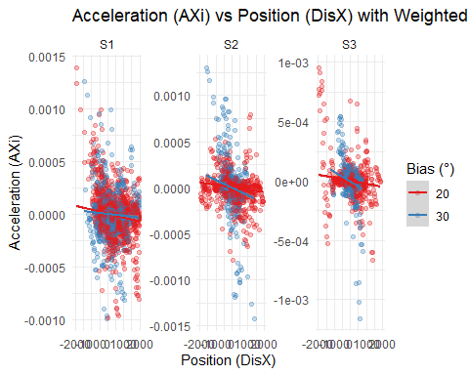

6.4 Correlation (weighted) & weighted regression per Session × Bias
#analysis_accel_position <- kin_data %>%
analysis_accel_position <- Acc_data %>%
dplyr::group_by(Session, Bias) %>%
dplyr::summarise(
#weighted_correlation = as.numeric(weights::wtd.cor(DisX, AXi, weight = PXpi)),
weighted_correlation = wtd.cor(DisX, AXi, weight = PXpi),
lm_model = list(lm(AXi ~ DisX, weights = PXpi, data = dplyr::cur_data())),
.groups = 'drop'
) %>%
dplyr::mutate(lm_results = purrr::map(lm_model, broom::tidy)) %>%
tidyr::unnest(lm_results) %>%
dplyr::filter(term == "DisX") %>%
dplyr::select(Session, Bias,
weighted_correlation,
regression_slope = estimate,
slope_p_value = p.value)
knitr::kable(analysis_accel_position, digits = 4,
caption = "Weighted correlation and weighted regression of AXi ~ DisX (by Session × Bias)")
Weighted correlation and weighted regression of AXi ~ DisX (by Session × Bias)
Session | Bias | weighted_correlation | regression_slope | slope_p_value
S1 | 20 | -2.061238e-01 | 1.964135e-02 | -1.049438e+01
S1 | 30 | -7.498104e-02 | 2.398854e-02 | -3.125702e+00
S2 | 20 | -1.629015e-01 | 2.732253e-02 | -5.962169e+00
S2 | 30 | -2.272117e-01 | 3.125219e-02 | -7.270264e+00
S3 | 20 | -1.834255e-01 | 2.942634e-02 | -6.233379e+00
S3 | 30 | -3.012130e-01 | 3.221770e-02 | -9.349301e+00

6.5 Aggregated view: weighted mean acceleration by DisX
mean_accel_by_DisX <- kin_data %>%
dplyr::group_by(Session, Bias, DisX) %>%
dplyr::summarise(
mean_AXi_weighted = w_mean(AXi, PXpi),
.groups = 'drop'
)
# Plot on aggregated means
ggplot(mean_accel_by_DisX, aes(x = DisX, y = mean_AXi_weighted, color = factor(Bias))) +
geom_point(alpha = 0.6) +
geom_smooth(method = "lm", se = TRUE, formula = y ~ x) +
labs(
title = "Weighted Mean Acceleration vs Position (DisX) — Aggregated per DisX",
x = "Position (DisX)",
y = "Weighted Mean Acceleration (AXi)",
color = "Bias (°)"
) +
facet_wrap(~ Session, scales = "free_y") +
theme_minimal() +
scale_color_brewer(palette = "Set1")
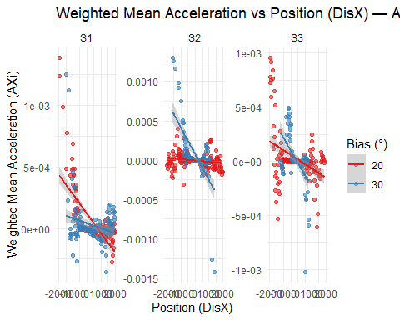
# Correlations and regressions on aggregated data
analysis_accel_position_aggregated <- mean_accel_by_DisX %>%
dplyr::group_by(Session, Bias) %>%
dplyr::summarise(
correlation_DisX_MeanAXi = cor(DisX, mean_AXi_weighted, use = "pairwise.complete.obs"),
lm_model_aggregated = list(lm(mean_AXi_weighted ~ DisX, data = dplyr::cur_data())),
.groups = 'drop'
) %>%
dplyr::mutate(lm_results_aggregated = purrr::map(lm_model_aggregated, broom::tidy)) %>%
tidyr::unnest(lm_results_aggregated) %>%
dplyr::filter(term == "DisX") %>%
dplyr::select(Session, Bias,
correlation_DisX_MeanAXi,
aggregated_regression_slope = estimate,
aggregated_slope_p_value = p.value)
knitr::kable(analysis_accel_position_aggregated, digits = 8,
caption = "Correlation & linear regression on aggregated weighted means (AXi vs DisX)")
Correlation & linear regression on aggregated weighted means (AXi vs DisX)
Session | Bias | correlation_DisX_MeanAXi | aggregated_regression_slope | aggregated_slope_p_value
S1 | 20 | -0.6770251 | -1.6e-07 | 0.00000000
S1 | 30 | -0.2329460 | -4.0e-08 | 0.00303325
S2 | 20 | -0.2230179 | -2.0e-08 | 0.00215490
S2 | 30 | -0.6543177 | -3.4e-07 | 0.00000000
S3 | 20 | -0.4054247 | -8.0e-08 | 0.00000005
S3 | 30 | -0.5306411 | -2.3e-07 | 0.00000025

