Supplementary Material

3. Study 1: Results
[Study1_Analysis.Rmd]

 | Trial | Bias | Duration
Familiarisation phase | Fixed objects, slow-moving object, perceptual crossing | 0° | 7 minutes
Session S1_Tracking | E1 | 30° | 60 s
Session S1_Tracking | E2 | 20° | 60 s
Session S1_Tracking | E3 | 30° | 60 s
Session S1_Tracking | E4 | 20° | 60 s
Session S2_Score-1 | E1 | 30° | 60 s
Session S2_Score-1 | E2 | 20° | 60 s
Break |  |  | 4 minutes
Session S3_Score-2 | E1 | 30° | 60 s
Session S3_Score-2 | E2 | 20° | 60 s
Protocol of the first experiment

(a) Spatial distribution of presence

Session | Bias | weighted_mean | weighted_median | Q1 | Q3 | weighted_var | weighted_sd
S1  S1 | 20 | 108.57778 | 20 | -140 | 320 | 160205.89 | 400.2573
S1  S1 | 30 | 72.48936 | 20 | -80 | 140 | 108452.91 | 329.3219
S2  S2 | 20 | 96.93277 | 100 | -40 | 220 | 109190.32 | 330.4396
S2  S2 | 30 | -26.44787 | -60 | -120 | 40 | 38517.97 | 196.2599
S3  S3 | 20 | -37.55853 | -80 | -180 | 100 | 96735.51 | 311.0233
S3  S3 | 30 | -66.03909 | -60 | -160 | 20 | 20826.89 | 144.3153
Table 1 S: Statistics on the distribution (density) of presence on the X-axis for the three sessions and the two biases

To show that the distribution is more dispersed at 20° than it is at 30° for the three sessions, a Levene's test is performed on the variances of the spatial distribution of presence in DisX:

Session | F-value | Df1 | Df2 | P-value
S1 | 3235.6 | 1 | 161851 | < 2.2e-16
S2 | 3104 | 1 | 121102 | < 2.2e-16
S3 | 14321 | 1 | 124575 | < 2.2e-16
Table 2 S: Test of homogeneity of variances between the three sessions

(b) Spatial distribution of mean velocities and accelerations along X
Session | Angle | Correlation DisX : MeanAcc | Pente regression | P value
S1 | 20 | -0.6842008 | -1.094480e-07 | 1.358768e-22
S1 | 30 | -0.2355605 | -4.501025e-08 | 3.073791e-03
S2 | 20 | -0.2217974 | -1.725121e-08 | 2.282418e-03
S2 | 30 | -0.5850876 | -2.380352e-07 | 1.316364e-10
S3 | 20 | -0.4052438 | -8.414706e-08 | 4.619111e-08
S3 | 30 | -0.3541626 | -1.252479e-07 | 3.046191e-03
Table 3 S. Correlations between average acceleration and position relative to C (DisX) for biases of 20 and 30°.

4. Calculation of the boundaries of static perceptual crossing
Under our particularly simple experimental conditions, in the intermediate region between the impossibility and the necessity of reciprocity, it is straightforward to determine geometrically the probability of reciprocity for a given distance of the partner relative to C (assuming equiprobability of X-positions). One calculates the proportion of positions in which the participant would be perceived by their partner among the positions in which they could perceive the partner (Fig. 1S). Reciprocity, thus defined in the observer’s descriptive space, corresponds to the geometric ratio of an objective probability.

B
B

A
A
A
A

x₂
x’₁
x₁
x’₂

Figure 1 S. In this particularly simple situation, for a given distance of participant B relative to C, the external observer can measure:
- the possible positions of participant A for which A receives a sensation (their receptor field crosses B’s body-object): x₂ – x₁
- the possible positions of participant A for which participant B receives a sensation (B’s receptor field crosses A’s body-object): x′₂ – x′₁
Assuming uniformity (i.e., spatial equiprobability of positions), one can then determine the probability of reciprocity for a sensation of participant A at a given distance of B relative to the center C. This probability is the proportion of positions where A is perceived among all positions where A perceives B: (x2​−x1​) / (x2​−x1′​)​
From this, one can determine the boundary of the region where this probability becomes zero—that is, the position beyond which there is no longer any possibility of static reciprocity. For a body-object of 20 units and a bias of 20°, this boundary lies 331 units on either side of C; for a 30° bias, it lies 149 units on either side of C.

6. Study 2: Results

 | Task | Trial | Duration
Familiarisation | 1 fixed object, 2 fixed objects, 1 slow-moving object, 1 faster-moving object
S1: Movement in X (X’) only | T1 (guide/follower) | E1 ; E2 ; E3 ; E4 ; E5 | 5 x 60 s
S1: Movement in X (X’) only | T2(instruction) | E1 ; E2 | 2 x 120 s
S1: Movement in X (X’) only | T3(score) | E1 ; E2 | 2 x 120 s
S2: Movement in X and Y (X’ and Y’) | T1 (guide/follower) | E1 ; E2 ; E3 ; E4 ; E5 | 5 x 60 s
S2: Movement in X and Y (X’ and Y’) | T2(instruction) | E1 ; E2 | 2 x 120 s
S2: Movement in X and Y (X’ and Y’) | T3(score) | E1 ; E2 | 2 x 120 s
S3: Movement in X and Y (X’ and Y’) | T1 (guide/follower) | E1 ; E2 ; E3 ; E4 ; E5 | 5 x 60 s
S3: Movement in X and Y (X’ and Y’) | T2(instruction) | E1 ; E2 | 2 x 120 s
S3: Movement in X and Y (X’ and Y’) | T3(score) | E1 ; E2 | 2 x 120 s
S4: Movement in X (X’) only | T3(score) | E1 ; E2 | 2 x 120 s

Protocol of the second experiment.

- Frequency distributions of A and B as a function of distance along X (DisX)
[Study2-Analyses statistiques_T1-T2.Rmd]
[Study2-PXpi_Trial-Analyses S2+S3_T1-T2.Rmd]

Tasks T1 and T2

Session | Task | Bias | Instruct. | Mean | SD | Q1 | Median | Q3
S1 | T1 | 20 | L | -115.35 | 135.44 | -220 | -60 | -20.00
S1 | T1 | 20 | R | 84.19 | 107.72 | 0 | 40 | 120.00
S1 | T1 | 30 | L | -26.54 | 83.24 | -80 | -20 | 0.00
S1 | T1 | 30 | R | 37.68 | 68.85 | 0 | 20 | 80.00
S1 | T2 | 20 | L | -94.92 | 155.60 | -200 | -100 | 40.00
S1 | T2 | 20 | R | 90.96 | 156.61 | -40 | 80 | 180.00
S1 | T2 | 30 | L | -60.07 | 95.19 | -120 | -60 | 0.00
S1 | T2 | 30 | R | 20.93 | 100.35 | -40 | 40 | 80.00
S2 | T1 | 20 | L | -181.82 | 202.66 | -260 | -120 | -40.00
S2 | T1 | 20 | R | 160.17 | 210.77 | 20 | 120 | 220.00
S2 | T1 | 30 | L | -287.38 | 358.20 | -360 | -160 | -60.00
S2 | T1 | 30 | R | 56.83 | 139.84 | 0 | 40 | 120.00
S2 | T2 | 20 | L | -205.55 | 200.62 | -320 | -160 | -40.00
S2 | T2 | 20 | R | 198.82 | 202.09 | 40 | 140 | 320.00
S2 | T2 | 30 | L | -229.35 | 300.37 | -280 | -120 | -60.00
S2 | T2 | 30 | R | 118.45 | 130.23 | 60 | 100 | 140.00
S3 | T1 | 20 | L | -248.97 | 213.91 | -380 | -200 | -80.00
S3 | T1 | 20 | R | 213.44 | 252.87 | 40 | 140 | 360.00
S3 | T1 | 30 | L | -133.01 | 182.51 | -180 | -100 | -40.00
S3 | T1 | 30 | R | 93.68 | 100.24 | 20 | 80 | 140.00
S3 | T2 | 20 | L | -303.45 | 285.61 | -440 | -200 | -60.00
S3 | T2 | 20 | R | 292.22 | 216.45 | 120 | 240 | 460.00
S3 | T2 | 30 | L | -206.57 | 235.07 | -240 | -140 | -69.87
S3 | T2 | 30 | R | 159.72 | 154.13 | 60 | 100 | 220.00

Table 4 S: Statistics of presence on the X axis (X') according to sessions (S1, S2, S3) for tasks (T1 and T2), angles (20° and 30°) and instructions (D, G).

Average accelerations in X as a function of distance to C

As in study 1, there is a correlation between the average acceleration in X and the distance to C (for sessions S2 and S3, point C moves according to the movements in Y (Y') of the two participants).

Session | S1 |  |  |  |  |  | S2
Task | T1 |  | T2 |  | T3 |  | T1 |  | T2 |  | T3
Bias | 20 | 30 | 20 | 30 | 20 | 30 | 20 | 30 | 20 | 30 | 20 | 30
Correlation | -0,18 | -0,17 | -0,12 | -0,10 | -0,20 | -0,23 | -0,06 | -0,11 | -0,10 | -0,12 | -0,06 | -0,13
Session | S3 |  |  |  |  |  | S4
Task | T1 |  | T2 |  | T3 |  | T3
Bias | 20 | 30 | 20 | 30 | 20 | 30 | 20 | 30
Correlation | -0,02 | -0,18 | -0,04 | -0,19 | -0,08 | -0,17 | -0,20 | -0,38

Table 5 S: Correlation between average acceleration in X and position in X (DisX).

There is still a negative correlation between acceleration in X and the distance between participants for sessions S1 and S4 without movement in Y. However, for sessions S2 and S3, this correlation is much weaker, certainly due to the possibility of movements in Y (Y') in depth. For the evolution of the variance in speeds as a function of distance from point C (set at 0), as for the correlations between acceleration and this distance, we find results similar to those of the first experiment.

Difference between the average positions on X during session S1 and sessions S2 and S3

Task | Bias | Instruction | Direction | n pairs | Median Δ (S2S3−S1) | W | p (one-sided)
T1 | 20 | R | Expected > 0 | 22 | 37.724 | 189 | 0.0221 *
T1 | 20 | L | Expected < 0 | 21 | -48.240 | 53 | 0.0156 *
T1 | 30 | R | Expected > 0 | 22 | 15.752 | 172 | 0.0720 ·
T1 | 30 | L | Expected < 0 | 23 | -31.002 | 52 | 0.0047 **
T2 | 20 | R | Expected > 0 | 19 | 108.498 | 148 | 0.0173 *
T2 | 20 | L | Expected < 0 | 19 | -80.316 | 41 | 0.0157 *
T2 | 30 | R | Expected > 0 | 18 | 74.436 | 145 | 0.0051 **
T2 | 30 | L | Expected < 0 | 19 | -37.740 | 29 | 0.0042 **
Table 6 S: Statistical significance of the difference Δ between the average positions on X during session S1 and sessions S2 and S3 for Tasks T1 and T2 and instructions Right (D) or Left (G).

Extreme centiles on X for Tasks T1 and T2
[Study2_PXpi_Centiles-DisX-.Rmd]

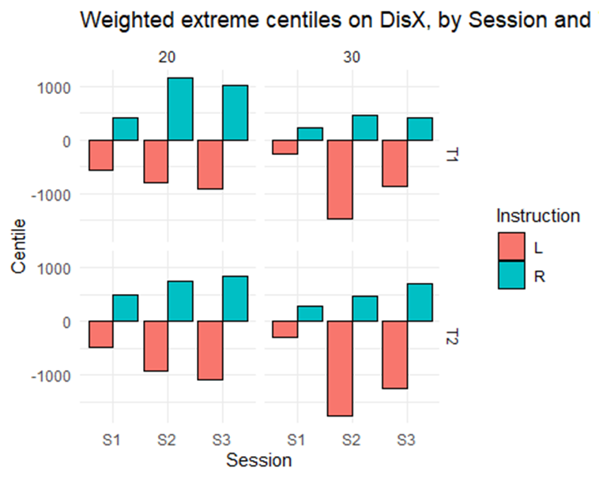
Figure 2 S: Extreme centiles of presence along DisX according to condition and instruction for the Tasks T1 and T2. The extreme centiles extend further in the instructed direction in S2 and S3 than in S1.

Task T3

Weighted statistics of presence in X (DisX) by session and bias for task T3
Session | Angle | n | Moyenne | s.d.
S1 | 20 | 205736 | 14.59 | 111.9
S1 | 30 | 210626 | 4.51 | 52.5
S2 | 20 | 104041 | -64.64 | 324.9
S2 | 30 | 81742 | 0.02 | 508.1
S3 | 20 | 107123 | -40.43 | 423.6
S3 | 30 | 94039 | -98.09 | 533.6
S4 | 20 | 211995 | -14.94 | 196
S4 | 30 | 225515 | 13.99 | 56.1
Table 7 S : Weighted statistics of presence in X (DisX) by session and bias for task T3

(b) Frequency distributions of C along X for Tasks T1 and T2.
[Study2_DisX_C-Boxplot.Rmd]
[Study2_sujetC_test_wilcoxon.Rmd]

Session | Task | Bias | D_mean | G_mean | t_ p.value | wilcox_p.value
S2 | T1 | 20 | 79.8964 | -89.5053 | 0 | 0
S2 | T1 | 30 | -16.5021 | -206.5697 | 0 | 0
S2 | T2 | 20 | 110.8821 | -94.9303 | 0 | 0
S2 | T2 | 30 | 24.0711 | -138.0569 | 0 | 0
S3 | T1 | 20 | 152.5649 | -127.5412 | 0 | 0
S3 | T1 | 30 | 16.5992 | -74.2639 | 0 | 0
S3 | T2 | 20 | 193.4474 | -208.0519 | 0 | 0
S3 | T2 | 30 | 67.9867 | -113.3575 | 0 | 0

Tab. 8 S. Distribution of C along X. Comparison between instruction Right (D_mean) vs Left (G_mean): t-test and Wilcoxon test

(c) Spatial distribution of presence along Y (DisY)

[Study2_DisY-Bias 20.Rmd] and [Study2_DisY-Bias 30.Rmd]
 |  |  |  | 20 ° |  | 30 °
Session | Task | Instruct. | Subject | Mean | Median | Mean | Median
S2 | T1 | R | A | 3.72 | 12 | -1.01 | -12
S2 | T1 | L | A | -6.73 | -12 | -18.24 | 0
S2 | T1 | R | B | -13.90 | -12 | -2.37 | -12
S2 | T1 | L | B | 19.94 | 12 | 44.59 | 12
S2 | T2 | R | A | -8.13 | 0 | -15.49 | -12
S2 | T2 | L | A | -4.87 | 0 | -10.66 | -12
S2 | T2 | R | B | -25.53 | -12 | -20.93 | -12
S2 | T2 | L | B | 21.83 | 12 | 28.64 | 12
S3 | T1 | R | A | 1.79 | -12 | -5.96 | -12
S3 | T1 | L | A | -7.38 | -12 | -9.45 | -12
S3 | T1 | R | B | -33.58 | -12 | -5.64 | 0
S3 | T1 | L | B | 31.32 | 12 | 20.29 | 12
S3 | T2 | R | A | -24.85 | -12 | -9.04 | -12
S3 | T2 | L | A | 2.78 | -12 | -16.53 | -12
S3 | T2 | R | B | -58.45 | -62 | -25.48 | -12
S3 | T2 | L | B | 42.68 | 37 | 28.97 | 12

Tab. 9 S. DisY weighted statistics by subject and instruction, Bias 20° and 30°, instruction Right (R) or Left (L).

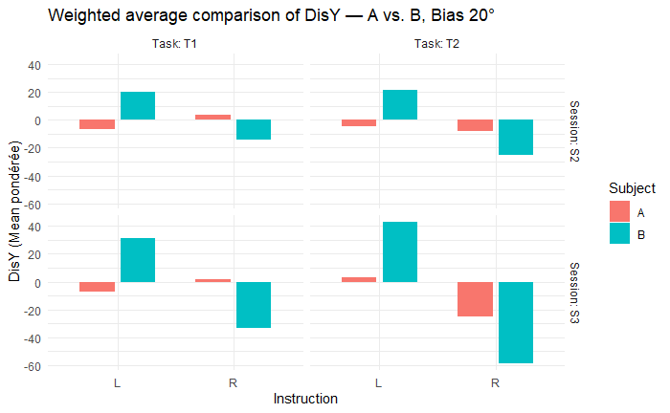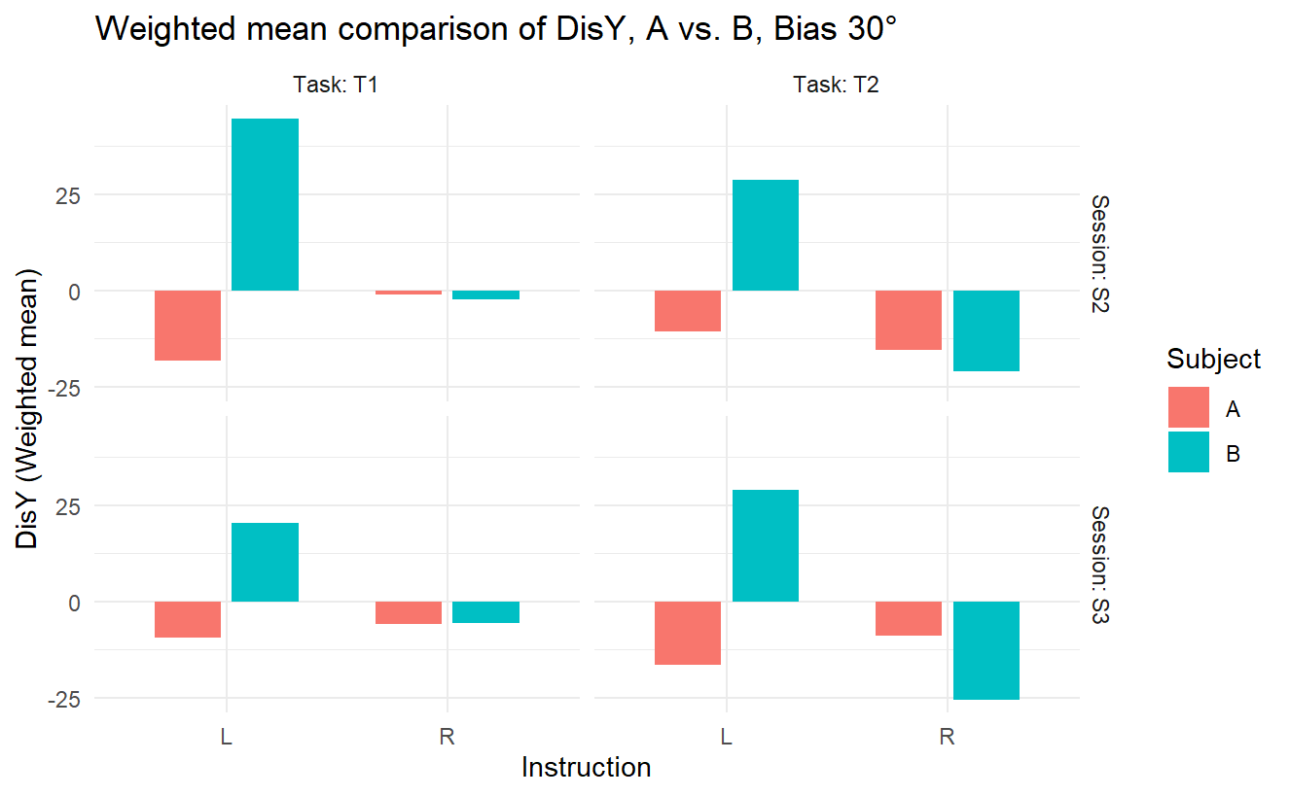

Figure 5 S: Spatial distribution of A and B along Y axis, Bias 20° et 30° for Tasks T1 and T2, and instruction Right (R) or Left (L).

 |  |  | 20° |  | 30°
Session | Task | Instruct. | statistic | p.value | statistic | p.value
S2 | T1 | R | 233928695 | 0 | 82602770 | 0.0368
S2 | T1 | L | 94666419 | 0 | 53072617 | 0.0000
S2 | T2 | R | 97655437 | 0 | 39488042 | 0.0000
S2 | T2 | L | 75276852 | 0 | 17361232 | 0.0000
S3 | T1 | R | 382222551 | 0 | 103534475 | 0.0000
S3 | T1 | L | 261719562 | 0 | 70930151 | 0.0000
S3 | T2 | R | 99305144 | 0 | 27163542 | 0.0000
S3 | T2 | L | 40993104 | 0 | 24180695 | 0.0000

Tab. 10 S: Wilcoxon test — comparison of A vs. B in each instruction

(d) Spatial distribution of vertical velocities

[Study2_Vertical velocities-.Rmd]

Vertical Velocity (VYpi) Mean ± IC95% (A et B), difference Δ and p-value of the one-sided Wilcoxon test (S2+S3 merged)

Task | Bias | Inst. | n_A | n_B | A: mean | B: mean | Δ = A − B | p (Wilcoxon dir.)
T1 | 20 | R | 7920 | 7920 | 9.4e-05 | -21.2e-05 | 3.06e-04 | < 2e-16
T1 | 20 | L | 7920 | 7920 | 2.93e-05 | 21.4e-05 | -1.85e-04 | < 2e-16
T1 | 30 | R | 8280 | 8280 | -8.17e-06 | -6.61e-05 | 5.79e-05 | 0.1188
T1 | 30 | L | 8280 | 8280 | -5.44e-05 | 24.7 e-05 | -3.02e-04 | 0.0000
T2 | 20 | R | 3960 | 3960 | -8.11e-05 | -39.1e-05 | 3.10e-04 | 0.0000
T2 | 20 | L | 3960 | 3960 | 9.41e-05 | 25.3e-05 | -1.59e-04 | 0.0000
T2 | 30 | R | 4140 | 4140 | -4.81e-05 | -12.6e-05 | 7.82e-05 | 0.0439
T2 | 30 | L | 4140 | 4140 | -7.8e-05 | 26.6-05 | -3.44e-04 | 0.0000

Tab. 11 S: Average speeds in Y for positions in X on the instruction side (DisX>0 for instruction Right (R) and DisX <0 for instruction Left (L). One-sided (directional) Wilcoxon test A vs B on VYpi — S2 & S3 merged (DisX rule respected).

